**Objective:**

That's a solid and accurate description of a **data story**. To help you apply or build on this concept, here’s a slightly refined and structured version of your explanation, which you might find useful for presentations, reports, or teaching others:

**What is a Data Story?**

A **data story** is a narrative approach to presenting data and analysis. It combines data, visuals, and storytelling techniques to communicate insights in a way that is both **engaging** and **easy to understand**.

**Key Components of a Data Story:**

1. **Introduction**
   * Sets the stage and provides context.
   * Answers the “why” behind the story: Why is this data important? What question are we trying to answer?
2. **Body**
   * Presents the data and analysis in a logical, systematic manner.
   * Often includes charts, graphs, and visualizations to highlight trends, comparisons, and key points.
   * Integrates narrative to guide the audience through the findings.
3. **Conclusion**
   * Summarizes key insights.
   * Highlights implications or recommended actions based on the data.
   * May include a call to action or next steps.

1.Story scene-1

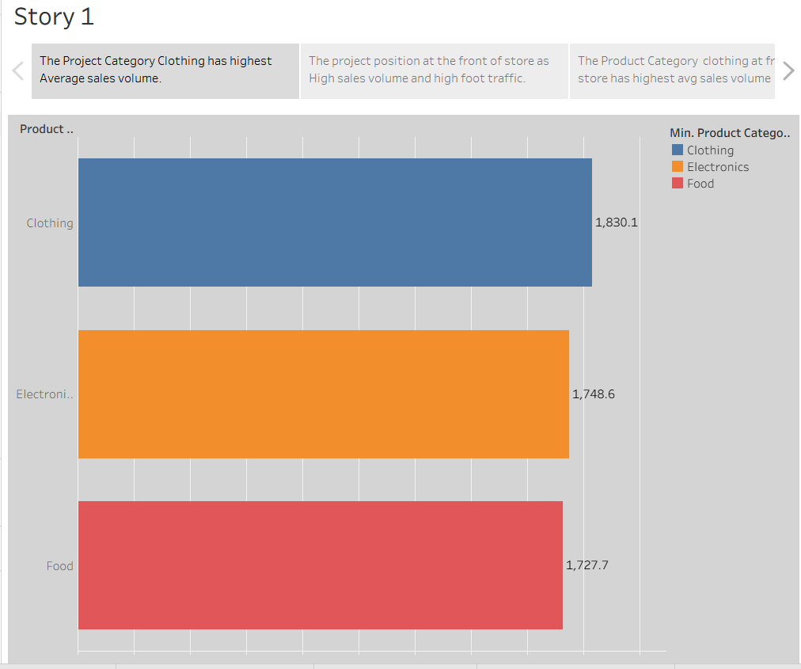

2.Story scene-2

.

3.Story scene-3

4.Story scene-4

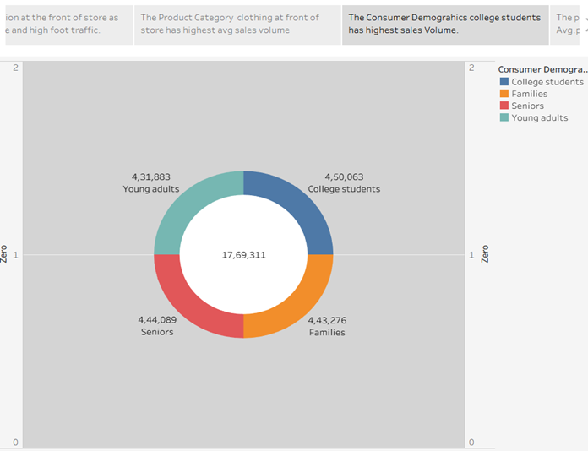

5.Story scene-5

